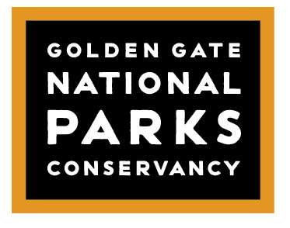
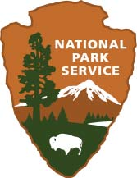

INTERNSHIP OPPORTUNITY

POSITION: VEGETATION ECOLOGY INTERN
ORGANIZATION: National Park Service Inventory & Monitoring Program
LOCATIONS: Sausalito, and Point Reyes Station, CA.
POSTING DATE: March 2, 2018.
OPEN UNTIL FILLED

OVERVIEW
The National Park Service Inventory and Monitoring Program (I&M) collects, organizes, analyzes, and synthesizes natural resource data and information in the San Francisco Bay Area Network of National Parks. This internship will support the I&M Vegetation Ecology program. For more information about the San Francisco Bay Area I&M and the natural resources it monitors, please visit: www.nps.gov/im/sfan and www.nps.gov/rlc/pacificcoast.

POSITION DESCRIPTION
The San Francisco Bay Area Network is seeking two interns to assist with plant community monitoring and invasive plant early detection protocols. The interns will work primarily in Golden Gate National Recreation Area and Point Reyes National Seashore, but will also make visits to Pinnacles National Park, and John Muir National Historic Site. One position will be stationed at Fort Cronkhite, Sausalito, CA, and one position will be stationed at Point Reyes Headquarters, Point Reyes Station, CA.

DESCRIPTION OF DUTIES
Plant Community Monitoring Program: utilizing point intercept techniques to read vegetation plots; recording data; navigating using GPS; installing permanent plot markers; photography; entering field data in a Microsoft Access database and performing quality-control checks; assisting with production of plot location manuals, using GIS, Google Earth, and MS Word.
Invasive Plant Early Detection Program: assisting in surveys for invasive plants; collecting data using GPS units and/or tablets; uploading/downloading field data on a web-based and/or GIS database and performing quality-control; Creating survey tracklogs and other map products in GIS and Google Earth.
Herbarium Work: Collecting, photographing, processing, scanning and pressing plant specimens for digital and physical herbarium accession.

BENEFITS
Gain experience identifying plants of the Bay Area, one of the most botanically rich regions in the California Floristic Province, a global biodiversity hotspot. Learn vegetation sampling techniques that are industry standards in land management and research. Become proficient in GPS and GIS technologies. Gain experience with photography, plant scanning and image management. Enjoy the scenery, wildlife, and cultural resources of spectacular National Parks while engaging park stewards. Professional development and training days are available to pursue interests in other departments within the Park Service and Parks Conservancy. Dormitory housing provided at Fort Cronkhite, Rodeo Beach, Sausalito. Thirty Dollar ($30.00) per day stipend.

DESIRED QUALIFICATIONS
Completion of one or more of the following college courses or equivalent experience: Botany, Plant Taxonomy, Plant Ecology, Field Methods in Ecology, Geographic Information Systems (GIS), Biostatistics. Basic computer literacy, Microsoft Word and Excel. Experience with database operations, ArcGIS, R, Photoshop, a plus. A valid driver’s license and clean driving record.

PHYSICAL REQUIREMENTS AND WORK ENVIRONMENT
This is a mixed position with field and office time each week. Must enjoy working in an office setting and outside in various weather conditions and terrains while maintaining a good attitude. Occasionally, field work can include up to 8 miles of hiking/day, most often, 1-2 miles/day. Must be able to lift, carry and position objects weighing up to 40 pounds. Field work is both on and off-trail, and frequently involves bushwhacking through dense vegetation. Interns will frequently encounter poison oak, ticks, spiders, mosquitoes, and other wildlife. While we have a comprehensive safety program, and provide protective equipment, please do not apply if you have any hesitation about the physical requirements and work environment.

TERMS
Desired Start Date: April 9, 2018.
Six month term, April – September, 2018.
Work week is Monday – Friday.
Two locations: Fort Cronkhite, Sausalito, CA; and Point Reyes Station, CA.

To Apply: Email your resume, a cover letter, and three references to Eric Wrubel at eric_wrubel@nps.gov

The Parks Conservancy and National Park Service seek to increase diversity in the workplace and reflect the changing demographics of our Bay Area community.
People of color and from all backgrounds are encouraged to apply.

