MapRun Planning Exercise

Step One - load the software

Load down the free Google software. It’s the only software that you will need.

It can be found here: https://www.google.co.uk/earth/download/gep/agree.html

Step Two - find your home

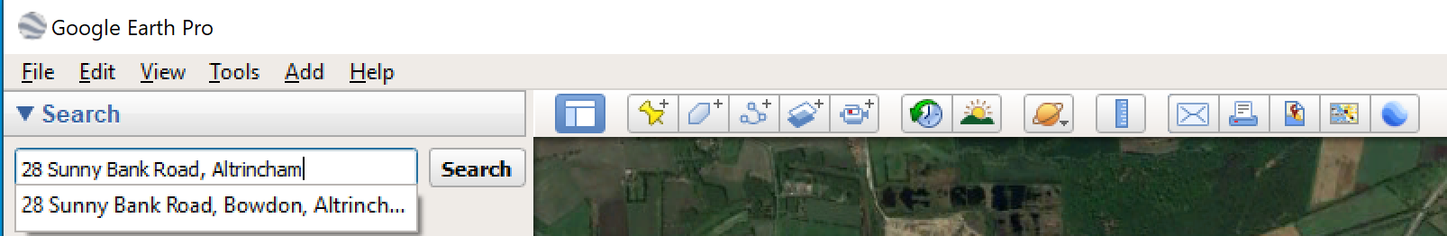
Open Google Earth Pro and find your home by typing your address into the search field and pressing ‘Search’.
Google Earth will zoom to your address. Zoom in further or zoom out using the mouse.

Step Three - use the orange man

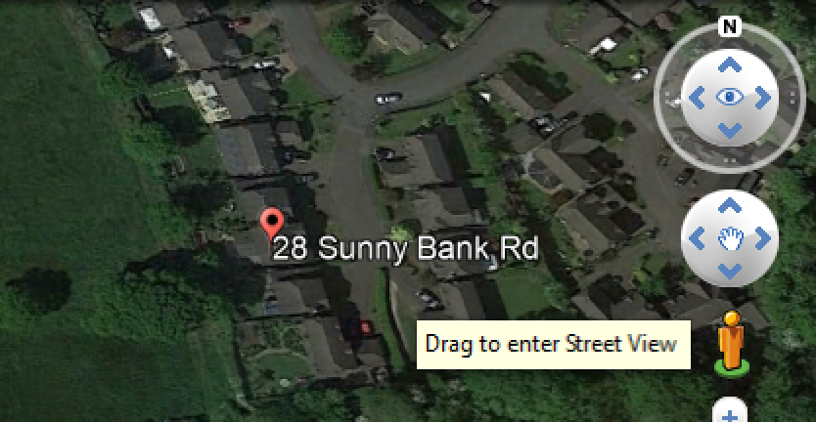
Get up close by dragging the orange man off his green pedestal and to your front door.

Use the mouse to look around, and maybe move up and down the road.

Step Four - add placemark (it’s Google for control site)

Use the yellow pin to add a placemark in the road outside your house.

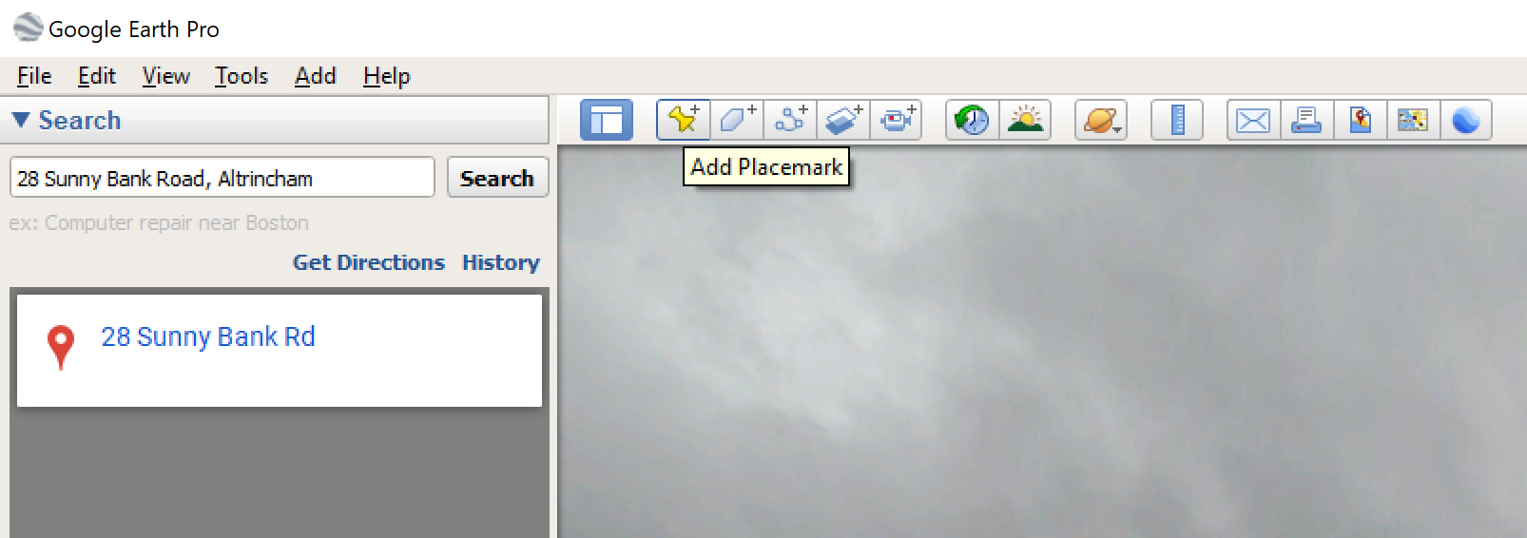
Click on ‘Add Placemark”

Then use the mouse to move the placemark to exactly the right place.
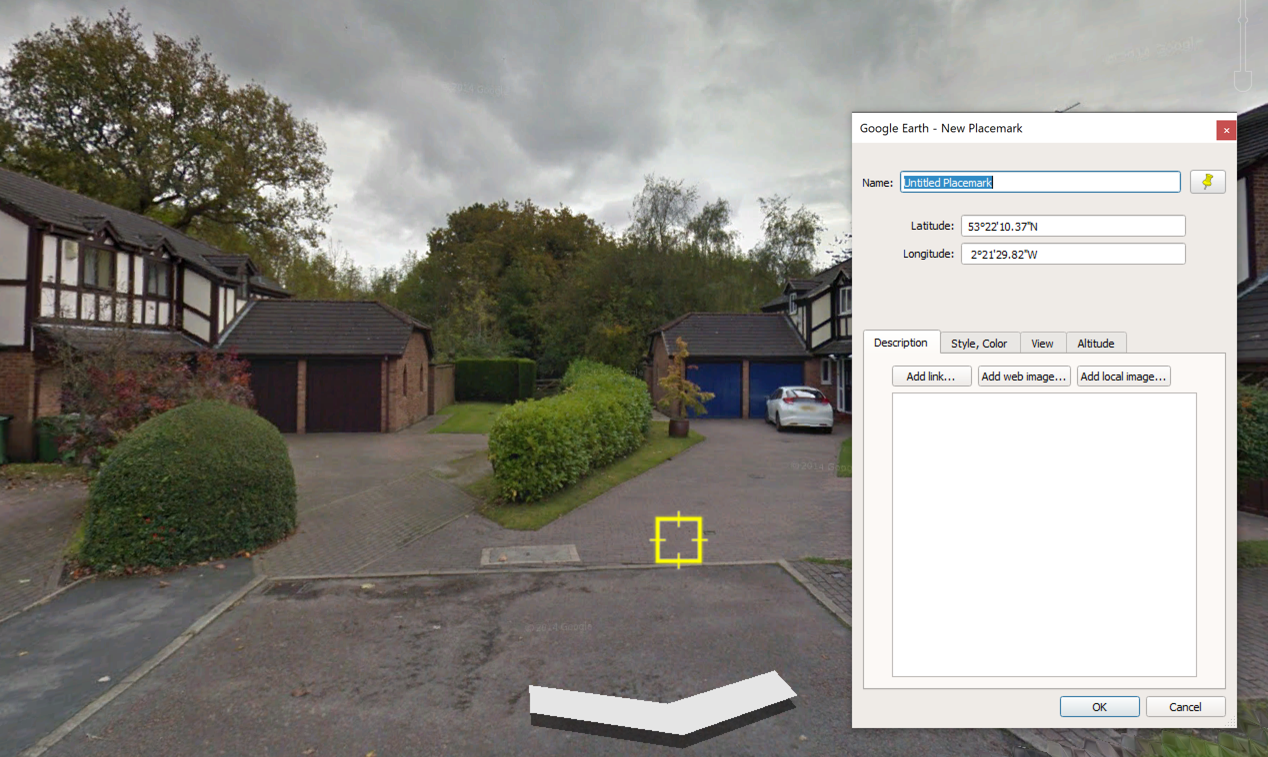

And name the placemark “S1” in the ‘Name’ field in the pop-up

This will be the Start of your MapRun course.

Step Five - check step four

Exit Street View - the button at the top RHS
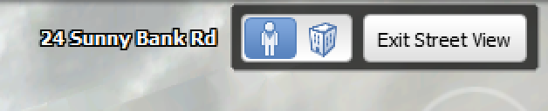

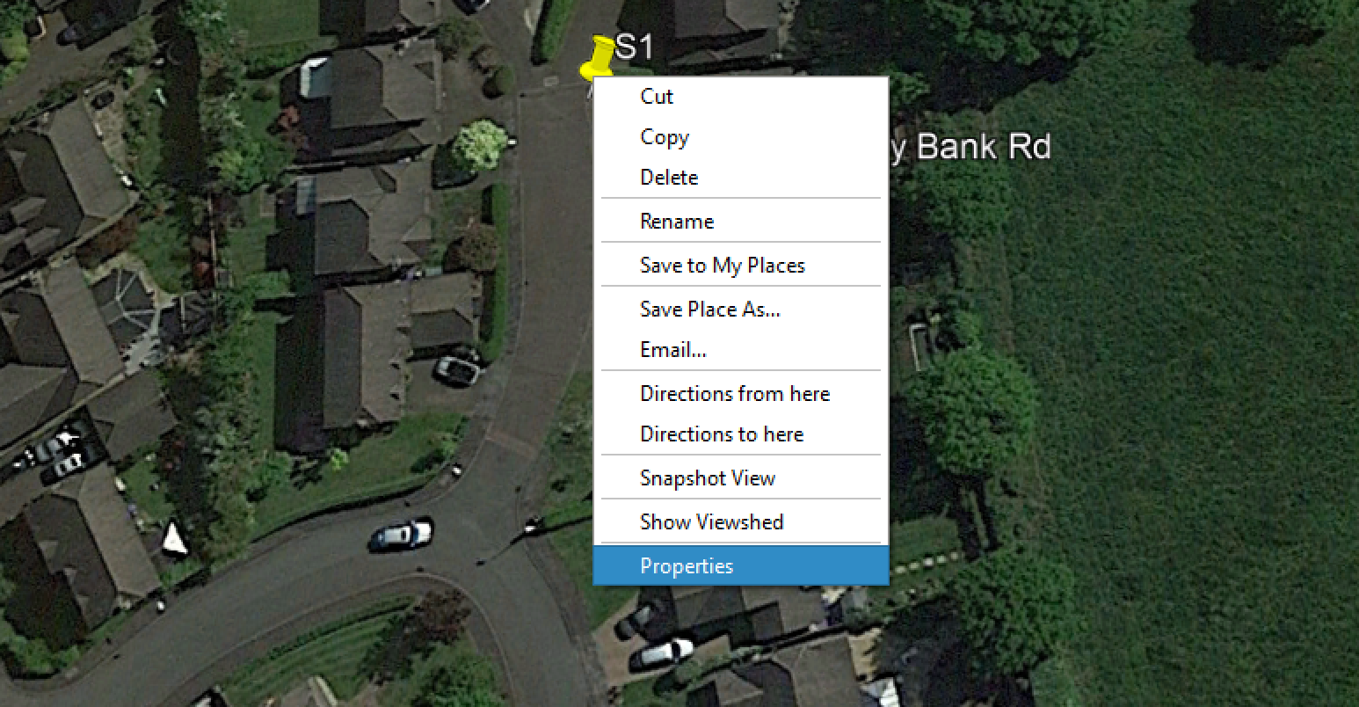
You will see “S1” from the helicopter view. (Press U and then N on the keyboard to set the map and give you a straight down view).

To change its position use right click>Properties and you will be able to move it.

And that’s it. You have created a MapRun control called S1.

Clearly some controls can only be created from the helicopter view but creating any control requires the same process of ‘Add Placemark”, checking the position, and giving it a name.

Step Six - plan a course

Add some more controls. Call them 1,2,3 etc and call the last control, the Finish, F1

This is all MapRun needs to define a MapRun course.

Step Six - the admin

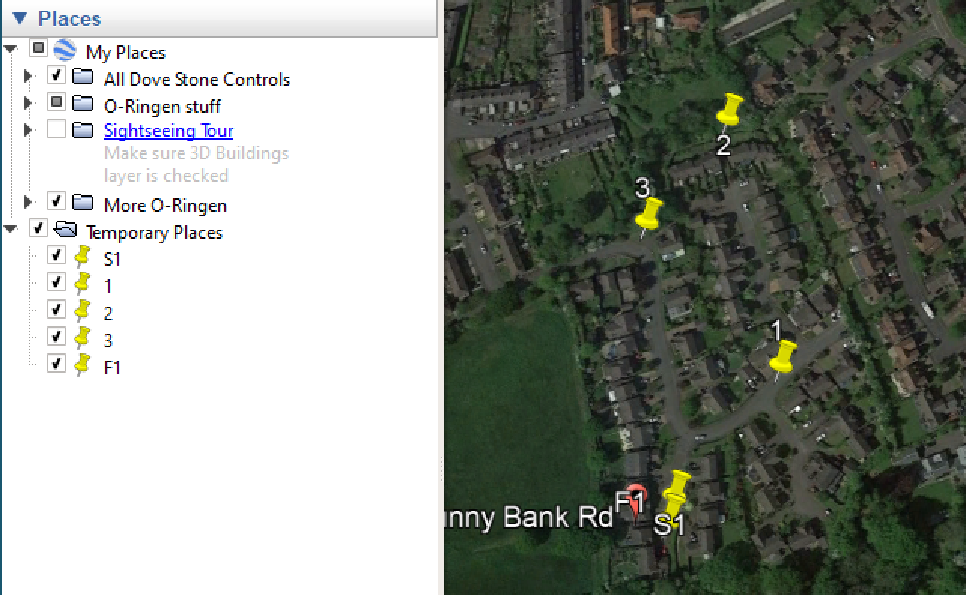
‘Places’ is Google Earth’s file handling area. Your controls should appear in ‘Temporary Places’. If they appear elsewhere then drag them into position.

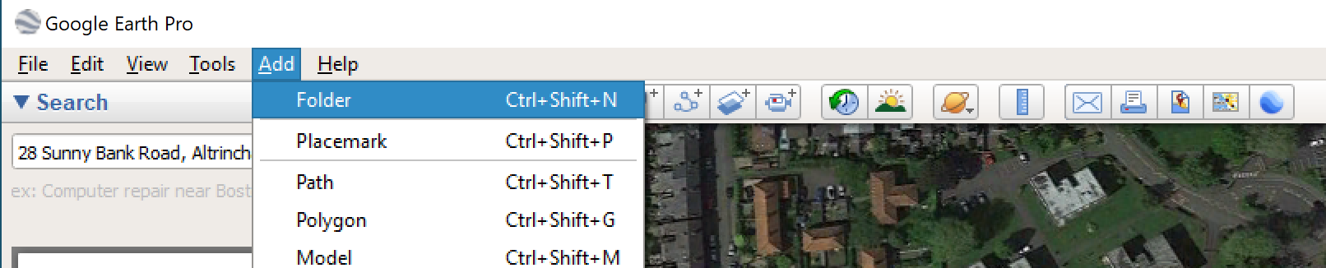
To create a folder in which to hold the controls click on ‘Add’ then ‘Folder on the top menu, and give it a name.

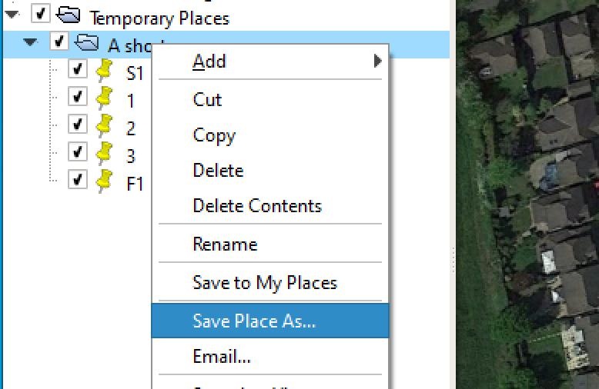
Drag your controls into the folder and then right click on the folder to save to the Desktop (or wherever) as a .kml file. (NOT .kmz)

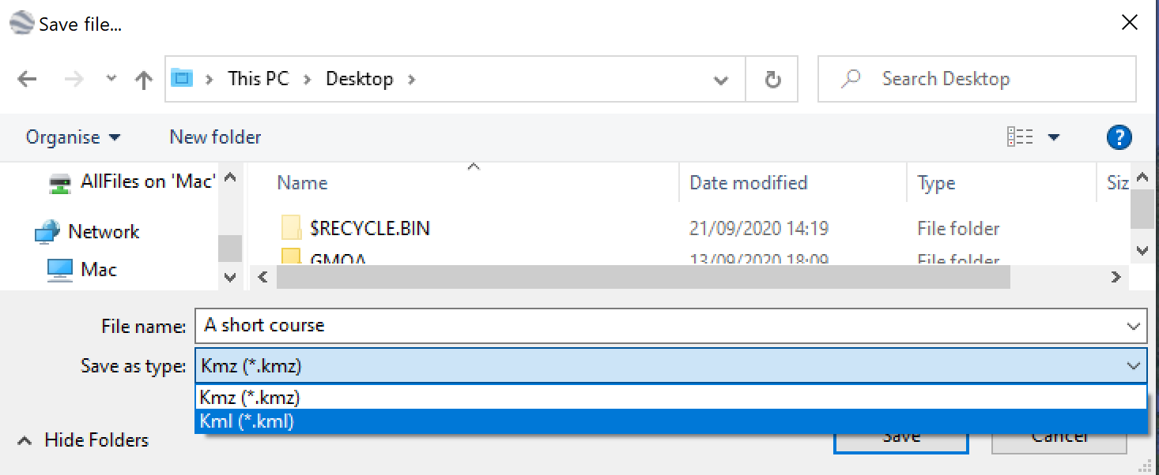

Send the file to me at navvies@btinternet.com and I will find the correct OOMAP, load it and your .kml file to the MapRun Server give you your very own MapRun course that starts at your own home.
