Lake District Double Championship Orienteering - 5th & 6th June 2021
Walking routes for competitors
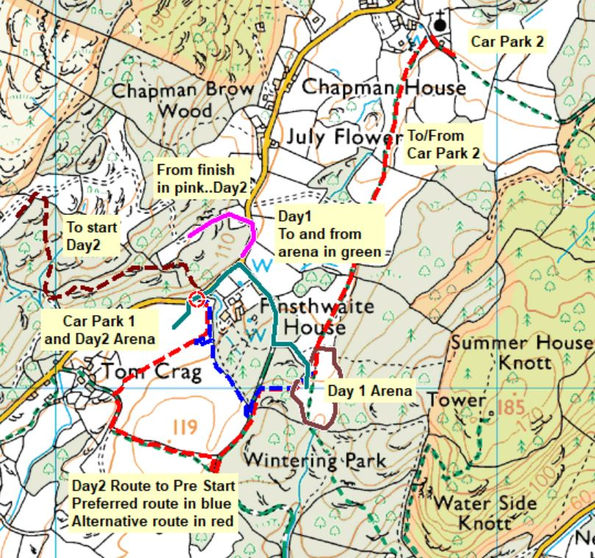
Entrance and exit gate for Car Park 1
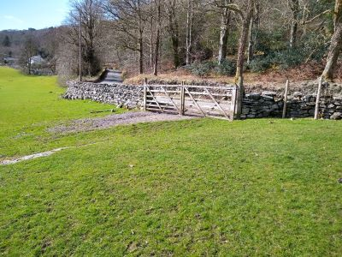
First call pre-start is at the red circle on the map and is shown in the foreground of this photo
Competitors will we released through the right-hand side of the gate around 30 minutes before their start time. They will turn right, walk a few yards and then cross the lane to enter the forest. The route is shown on the map above and will pass close to the finish where clothing can be left.

