Welcome to Altrincham

We hope that you come to Altrincham for the third NSL event.
It should be fun. It starts at the Start. Not too far from the Start is Altrincham’s complex town centre. This is good: it means it won’t be too much of strain to run into a navigationally challenging area.
The town is split into east and west by the railway. This creates a navigational complication that mustn’t be forgotten. Check the whereabouts of the footbridges. You may have to run through the Interchange.
Away from the town centre it will be possible to run unlit paths which, if not exactly in the country, can be quite grassy creating an opportunity for those who want to run off-concrete for a while.
In addition, the suburbs of Altrinham, Hale and Bowdon are all within reach. (Sadly, not Timperley; too much a good thing and all that.) Anyway, it is flat runnable terrain, and there’s lots of it. Choices to make.
Fun.

Registration: The Malt Shovels
Registration and the Start and Finish will be at the Malt Shovels. It is at 68 Stamford Street, WA14 1EY.
We will be given our own area; the landlord is very encouraging, and the beers are excellent.

Parking
There is some – not very much - roadside parking next to the pub and this is free after 5.00pm but £1.20 before that.
There is a huge car park – free after 6.00pm, but £1.20 before then – to the east of the Interchange (the bus bus, Metro and Train station). The Planet Ice skating rink runs along the southern edge. The address is Oakfield Road, WA15 8EW. You are certain of a place to park here.
It is only 450m from this car park to the pub. The simplest way is via a footbridge over the railway.
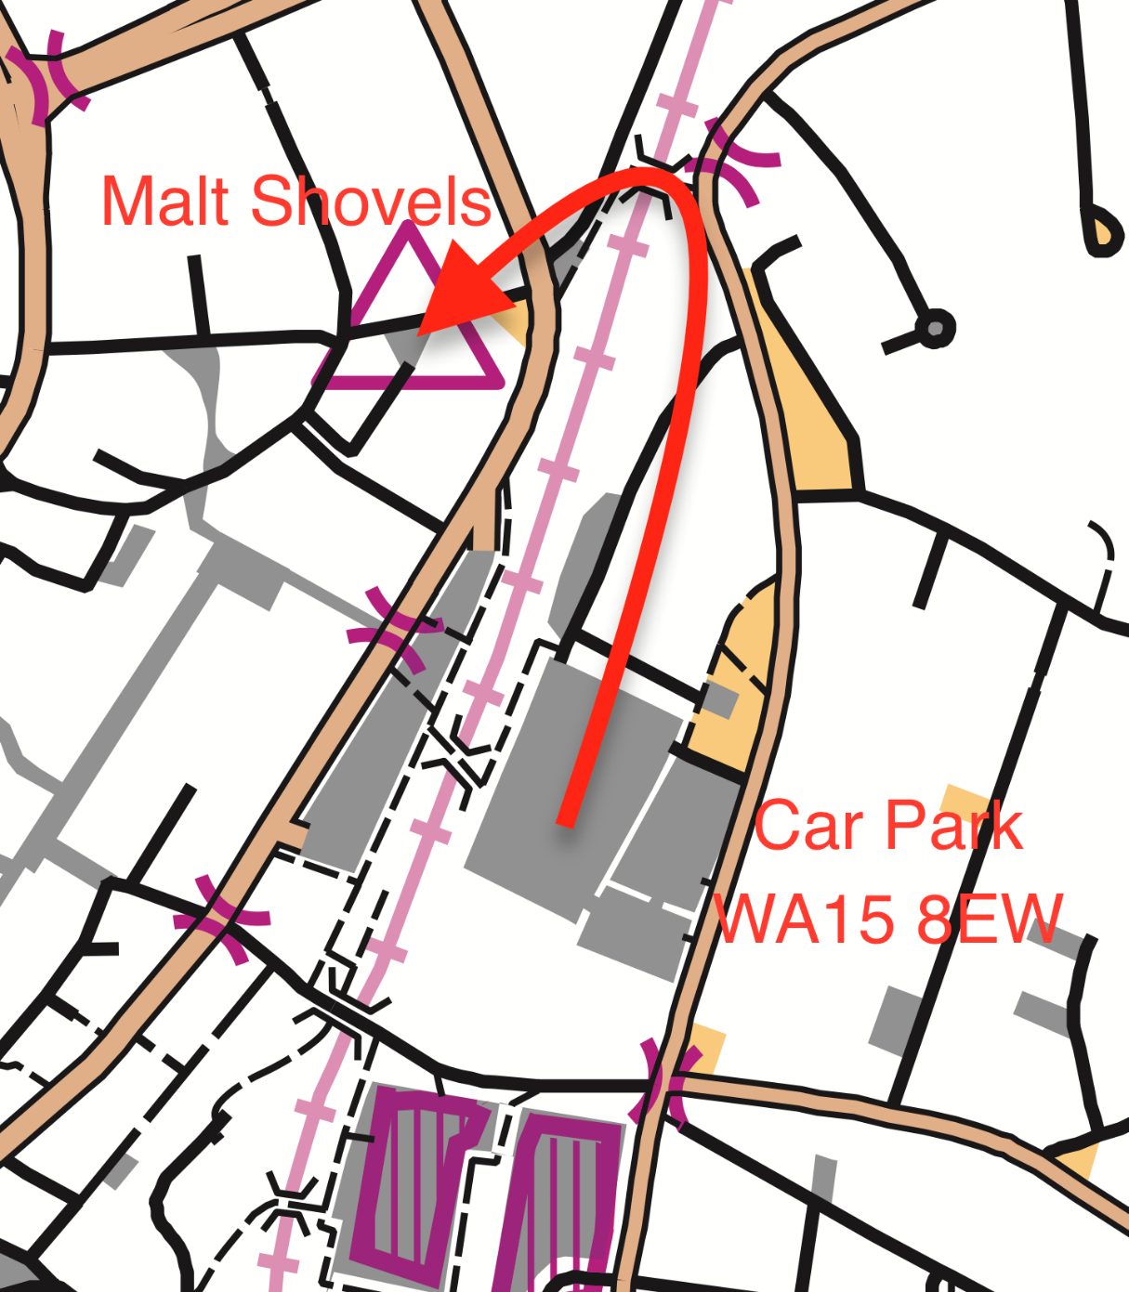

Eating in Altrincham

The Malt Shovels does not do food. However, there are plenty of places in Altrincham that do.
Some lovely restaurants are close to the Malt Shovels and except for the New Don they are all on the way back to the car park (ish).
Here is a selection.

The New Don
Beloved Chippy just up the road at 2 Church Street 200m

Bistrot Pierre
French Bistro 330m

Nando’s
South African Cuisine 350m

Jaipur Palace
Indian Vegetarian and Vegan 370m

Tre Ciccio
The Italian’s Italian 400m

Sugo Pasta Kitchen
Posh Pasta 440m

Porta Tapas Bar
Spanish Tapas 440m

