Saturday January 8th 2021
John o’ Goats charity event at Lyme
Final Details
www.mdoc.org.uk

Venue Lyme main car park, Disley, near Stockport SK12 2NX
Entrance on A6 just west of Disley Village GR SJ 964 823

Lyme park Entrance fee free to National Trust members, otherwise adults £8, children £4 for all individuals entering the park in a car. Lyme Park is free to all who walk into the park via any gate, including the main car entrance.

Entries Everyone should pre-register using the MDOC Registration System https://mdocentry.org.uk. This will guarantee a map is available, EOD will be limited. Entries close Thursday 6th January.

Registration 10.00 – 10.45 in the car park.
Please do not arrive before 10.00 as there is a Park Run.
Entry Fee Free but donations to the charity please

Courses John o’ Goats’ is the MDOC version of the annual American head-to-head Billygoat race. Long, medium, short, and very short competitive courses available with age group handicapping.
Course | Long | Medium | Short | Very Short
Miss 2 | M21, M35 | W20, W40, M16, M55 | W16, W55, M70 | W70, M80
Miss 3 | M20, M40, M45 | W18, W45, M60 | W14, W60, M12 | W75, M85
Miss 4 | W21, W35, M18, M50 | W50, M14, M65 | W12, W65, M75 | W80+, M90

There will be an easy (yellow) course for families and novices.
SI punching. Dibbers may be borrowed. Courses close at 13.00

Prizes For Long/Medium and Short: Top 3 males and top 2 females
For Very Short: Top male and top female
Yellow: Winner, with lollipops for all contestants.

Mass Start 11.00 prompt. Start is at the Cage (Tower on your left as you drive in). It is 750m from the car park. Allow 10 to 15 minutes.
Yellow course will aim to start at 11.05.

Separate starts for each course see below:
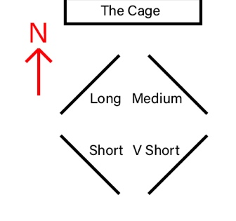

Footwear Suitable footwear is required for exposed grassland and woodland with some steep slippery slopes and occasional rocky areas. No spikes allowed.
Clothing Please ensure suitable clothing to include cagoule as forecast is cold and wet.

Finish Near the car park
Prizegiving and raffle draw at 12.30. in the car park

Charity 10 local scouts from Macclesfield and Poynton, including one MDOC member, have been chosen to represent the UK at the World Scout Jamboree in Korea in 2023. Donations will be going to Macclesfield District Scouts to support their participation. Donations can be Gift Aided. Apart from paying the BOF levy, all donations will go to the charity as MDOC donates all costs of running the event.

Raffle There will be a raffle with prizes donated by club members. Takings will be donated to the charity.

Facilities Toilets and Cafe in the Timber Yard. 5 minutes from car park.
Dogs Under close control in the park and on leads near livestock and vehicles.

Officials Planners – Ben and Alain Kyd
Organisers – Rhys Beynon / Catriona Beynon (W14)
Controller – John Britton
Enquiries lyme2022@mdoc.org.uk

