Sale NE Safety Brief

The competition area is flat and predominately suburban, with several open areas. Easy to run. However,

There are three major hazards

A particularly busy road

Brooklands Road is a straight, busy single carriageway that runs roughly North/South cutting the competition area into two of which one third is to the west and the rest to the east.

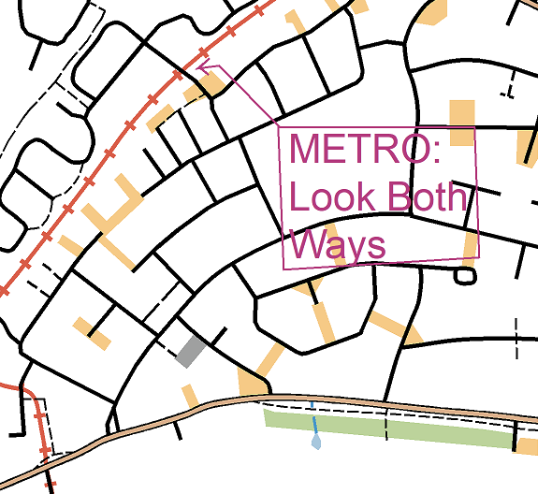
It has three pedestrian crossings, and all have been mapped. Controls have been placed to encourage their use, but the straightness of the road makes for good visibility and the crossing are not compulsory.

There is a busy roundabout at the southern end, but the road can be crossed easily enough thanks to a central reservation - as per the map.

The MetroLink

There is one MetroLink road crossing without barriers or lights. The warning signs say: “Look both ways”. From experience, this is very good advice. The trams are surprisingly quiet and could arrive from either direction – simultaneously.

The brooks/streams

There are several brooks/streams that cross the competition area. They flow in dangerous deep, steep-sided channels and are not to be crossed except by bridge.

and possibly also

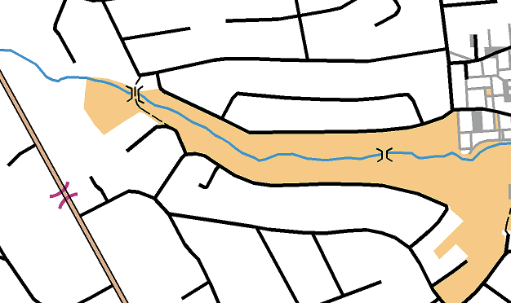
An untrustworthy cat

A sign on a door near control 52 warns passersby to “beware of the dog” and informs that “the cat is untrustworthy too”. We’ve met the dog. It is quite friendly. We’ve yet to meet the cat……

