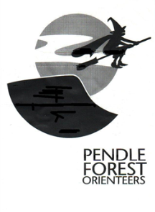 PFO Barley Level C Event - Pendle Hill

Date of event: Sun 03rd Feb 13
Type of event: District (C)
Nearest town: Barley Village, twixt Clitheroe and Nelson
This is the first orienteering event over the eastern part of Pendle Hill for many years.
The original paper map has been 're-mastered' into OCAD so that significant alterations, such as new fences and paths, can be added.
Weather and equipment: The summit of Pendle Hill is at 557m and this is February!! Snow and ice may be around, with additional wind-chill at all altitudes. You must come prepared as the controller is very likely to make carrying whistles and water/windproof jackets compulsory. Check the forecast to determine whether carrying hats, gloves and additional thermal layers will be necessary or advisable.
Keep an eye on our webpage in the week before the event for final instuctions on advised clothing.
PROVISIONAL COURSE LENGTHS & CLIMBS:
Final details will be announced nearer the competition date.
White |  |  | Not available - terrain not suitable
Yellow | 2.4k | 60m | TD2 - Valley, max altitude 300m
Orange | 2.8k | 100m | TD3 - max altitude 400m
Light Green | 3.6k | 170m | TD4 - max altitude 400m
Green | 4.2k | 190m | TD5 - max altitude 450m
Blue | 6.1k | 240m | TD5 - max altitude 450m
Brown | 8.8k | 315m | TD5 - max altitude 557m
All courses, including Yellow, are on exposed terrain.

Times
Registration opens at 9:45 till 12:00.
Starts from 10:30 to 12:30. (The Start is approximately 2km and 100m climb from Registration along a good vehicle access track. Allow 30 minutes for slow walkers.)
Courses close at 2:30PM

Entry Details
EOD only.
Seniors (M/W21+) £7.00
Juniors (M/W20-) £3.00.
Dibber hire £1, but £30 if lost

Full details, location map etc see www.pfo.org.uk/events/pendle-hill-jan-23-2013

