Don’t black lives matter if those “vaccines” take them?

How propaganda hides the genocidal impact of the COVID-19 “vaccination” program

By Mark Crispin Miller

A “coincidental” death in India

What happens when a propaganda blitz goes wrong, and proves (or seems to prove) the very truth it was devised to blow away? Let's see.

On Thursday, April 15, Vivek, the beloved Indian actor and comedian, was declared a "health ambassador" by Tamil Nadu's Health Secretary, J. Radhakrishan, who enlisted Vivek's "star power" (as The Hindu reported) to encourage "differently abled persons, athletes, shopkeepers and persons who have undergone organ transplantation" to get their COVID-19 "vaccinations." Vivek dramatized the "safety" of those jabs by getting one himself:

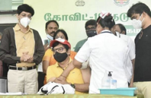

Tragically, that propaganda missile, launched on Thursday, crashed and burned on Friday, when Vivek suffered cardiac arrest, "fell unconscious at his house in Chennai," and was hospitalized in critical condition. He died, at 59, on Saturday (a passing largely unreported in the Western press).

Vivek's hospitalization prompted a barrage of articles denying that his COVID jab had anything to do with it. "Actor Vivekh's heart attack severe, not related to COVID-19 vaccination: Hospital" (New Indian Express). "Actor Vivek's cardiac arrest not linked with COVID-19 vaccine, says TV Health Sec'y" (News Minute and Yahoo! News). Saturday's obituaries kept it up, although more quietly, the exculpation buried in their later paragraphs—as at the end of this report from MSN:

"On Thursday, Vivek received his first dose of Covid-
19 vaccination at Omandurar government hospital," reports said.

However, the hospital as well as Tami Nadu's health
secretary J Radhakrishnan told a press conference that the Covid-19 vaccine was unlikely to be the cause of the cardiac
arrest.

10 more “coincidental” deaths in the United States

Now, it may be true that Vivek's fatal heart attack was unrelated to his COVID-19 jab the day before. The team who tried to save him said, reportedly, that they discovered a 100% blockage in his LAD (left anterior descending artery), and performed an emergency angioplasty. So the timing of his public jab and sudden death could well have been just horribly coincidental—or maybe not, since Vivek's post-jab death is not the only one that's made some news (or not).

Drene Keyes

On January 30, Drene Keyes, a 58-year-old minister at the Church of Abraham in Gloucester, Virginia, and a grandmother of six, got her first Pfizer shot, in hopes it would protect her from COVID-19: "Keyes had diabetes, sleep apnea, and was obese," reported WKTR-TV in Norfolk. "Her job made her eligible for the first dose." Keyes felt ill right after the injection: "Something is not right. Something's not right," she said as she left the clinic, then started vomiting, unable to breathe. Soon after, she was rushed to VCU Tappahanock Hospital, where they tried to purge the fluid from her lungs, due (the doctors told her daughter) to a flash pulmonary edema, caused by anaphylaxis—which, within just a few hours of her injection, killed her.

The TV station's coverage of Keyes' death included some poignant comments by her daughter, Lisa Jones: "My mom was wanting to protect herself, but it did not turn out that way."

Jones believes more research needs to be done,
especially for those with underlying health issues.

"Why are we allowing people with underlying conditions
to be guinea pigs for a vaccine that is still in clinical trials and emergency use?" Jones questioned.

She is hoping this serves as a warning for people to see
their doctors and be pre-screened prior to being vaccinated.

"The pain my family feels from this unexpected loss
should not be repeated for others," said Jones.

That local story, with its tacit focus on the welfare of its viewers, was notably unlike the rendering by NBC News—boilerplate so Pharma-friendly that Pfizer could have written it (and maybe did): "Virginia woman dies shortly after Covid vaccination, though no link has been found," claimed the headline, followed by this repetitious lede:

A Virginia minister died shortly after she received a
coronavirus vaccination, authorities said Friday, though
there was no indication the vaccine was at fault.

After identifying the departed, and noting where she had been given the shot that did not kill her, shortly after which she died, NBC's reporters tell us once again that, according to "officials," that shot had not killed her:

Officials said they did not know the cause of death, or any
underlying conditions Keyes might have had that could have
contributed to her death, and said there was no evidence it was tied to the vaccination.

After a paragraph reporting that Keyes was rushed to the hospital, we're told yet again that that injection, just a few hours after which she died, bore no relation to her death:

While an official cause of death was not immediately
determined, Keyes did not die from any allergic reaction
connected to the vaccine, according to state Health
Commissioner M. Norman Oliver.

"We can confirm that the death occurred within hours of
having received the vaccine, but that is not evidence of it
being related. We are currently investigating and do not yet know the cause of death."

NBC then bolstered that assurance of a state investigation with a statement from the CDC, which, having offered its condolences ("Our thoughts are with the family during this heartbreaking time"), noted its shared interest in determining what killed Drene Keyes: "CDC continues to closely monitor the safety of all vaccines, and we are actively working with Virginia officials to fully investigate the situation."

But there was no investigation, with or without the CDC, despite the family's insistence on an autopsy; nor would officials say why they refused to do one. "The state eventually [somehow] determined Keyes, a minister, died of complications from COVID-19—Oliver wasn't sure if Keyes knew she had it—and hypertensive cardiovascular disease," reported the Virginia Mercury on March 12, noting also that, according to a private autopsy ordered by Keyes' family, Keyes did not have COVID-19.
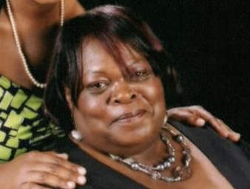

Karen Hudson-Samuels

Ten days after Keyes' sudden death, on February 9, Karen Hudson-Samuels, a media historian, and former anchor, producer and news director at WGPR-TV, the nation's first black-owned and -operated TV station, was found dead, by her husband, in their home, one day after her first COVID-19 "vaccination." Unlike Vivek, Hudson-Samuels had not publicized her jab; but the "Detroit media icon" was so famous and beloved in that city, and her death, at 68, so unexpected, and so soon after her jab, that it made many headlines starkly contradicting the official line that those "vaccines" are completely "safe." The story was reported all throughout the Detroit media, and, elsewhere, on Fox News, and by the New York Post and Daily Mail. (The news was not reported by the New York Times, or any other major liberal outlet.)

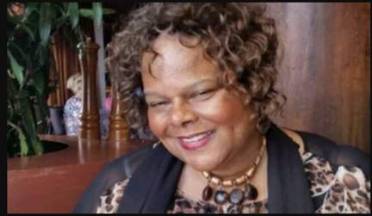

Kimberly Credit

The day after Hudson-Samuels died, Dr. Kimberly Credit, the first female pastor of Mount Zion Baptist Church, in Boonton, New Jersey (and founder of a podcast called The Preaching Lab), publicly received her first injection of the Moderna "vaccine," as a way to tell the rest of her community, "Go thou and do likewise." "As a leader," she wrote on Facebook, "I want to lead by example[,] especially for Pastors and the African American community."

Got my first vaccine dose today. Thank you to Pastor
Joe Carter for his leadership in pulling Black Clergy
together and for allowing me to pray live for our news
outlets. Thank you New York Times and Channel 2
News for interviewing me. #DoTheResearch #BeInformed
#OurTrustInGod #WeNeedEveryoneVaccinatedToEndThis

Though she made no public mention of it, Dr. Credit was presumably injected for the second time 28 days later, on March 10. Throughout the interim, and afterward, she posted nothing about feeling ill, not even after surgery. On Easter Sunday morning, April 4, at her church pulpit, she told the congregation, passingly, that she was short of breath. Afterward she posted the details of her next day's podcast (on "Preaching in a Pandemic"), with this prefatory sentence: "Listen ... let me say this before I get a good and needed nap in."

Then, on April 5, minutes before that podcast: "Suddenly, without warning, Rev. Dr. Kimberly Credit entered eternal rest," as her obituary puts it. Her death, at 44, went unreported, except here and there online, where admirers shared their shock at her untimely passing. (“It’s hard for me to believe this,” wrote Ann Brock on her blog, The Old Black Church. “This was one anointed woman of God.”) The only outlets that took note of Dr. Credit’s evidently fatal “vaccinations” were COVID-dissident sites like Daily Exposé, in the UK: “Young Pastor DIES After Taking, and Promoting, Moderna COVID-19 Vaccine.”

(Although, in her Facebook post on Feb. 10, she thanks the New York Times and CBS affiliate WLNY-TV for covering her first injection, there seems to be no mention of it in their archives.)

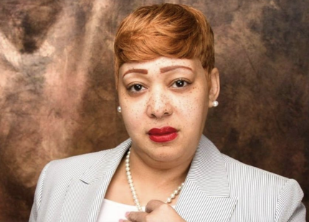

So, if Vivek's post-jab death was a "coincidence," are his and those three others just "coincidental," too? If so, the gods of Chance have certainly been working overtime in 2021, since those three aren't the only such fatalities; though noting them requires that we step back and take a longer view of just how "safe" those "vaccines" really are.

Midwin Charles

On March 1, Midwin Charles, the dazzling Brooklyn defense attorney who often popped up as a legal analyst on CNN and MSNBC, told her multitude of Twitter followers that she'd just got the first of her two Pfizer jabs ("qualified because of my asthma") "at a FEMA center," where the "[p]rocess was organized, efficient, and everyone is kind and in a good mood. Let's do this!" Charles also urged the jab on her own mother, who finally gave in after "weeks of convincing," according to another of the lawyer's many online posts, which hint that the effects of the "vaccine" were not as pleasant as her visit to that well-run FEMA center.

There was, at first, "a little soreness at vaccine injection site," and then, a few days later, "mild fatigue" and some "shortness of breath." Thereafter, Charles posted nothing on her health, until March 19: "HEY GUYS!" she wrote on Instagram. "HAPPY HOUR TONIGHT IS CANCELED. I'M NOT FEELING WELL. SEE YOU NEXT FRIDAY." A few weeks later, on April 7, Charles died, at 47. Her family did not disclose the cause of death, nor has any media outlet reported it.

While there were, strangely, few obituaries in the corporate press (the New York Times did not report it), online there was an outpouring of grief from Charles' friends and colleagues: "Midwin, you were a brilliant spirit and beautiful soul. You were such a blessing," posted MSNBC's Joy Reid. "I'm just stunned, and have been since I learned of this today." The likely cause of Charles' death went tactfully unmentioned then, nor has it come up since, not there or anywhere throughout the media, whether corporate or left/liberal. The Sun and Daily Mail each ran a big obituary piece playing up the seeming mystery of Charles’ death. The likelihood that she was killed by her “efficient” Pfizer “vaccination” was noted only by LifeSite News, a Catholic website, on April 9, with a headline as pitiless as it is accurate: "TV personality who boasted of being vaccinated, pressuring her mom to do the same, dies after receiving jabs.”
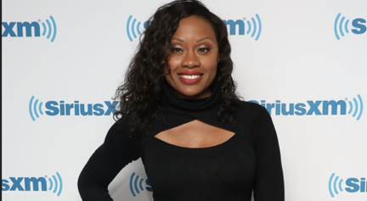

Joshimar Henry

One of the first Chicagoans to get Dose #1 of Pfizer's COVID-19 "vaccine" on December 15—an event covered live, and breathlessly reported, on MSNBC—was Dr. Joshimar Henry, who marked his second shot, on Jan. 6, on Facebook, where, like Vivek and Midwin Charles, he used his own experience to counter what he called "the hesitancy of many" to get jabbed: "Initially I was also hesitant but was reassured with some research and clarifying my doubt through reading." He'd just had the shot, and, "like many of his colleagues" at Norwegian American Hospital, was just fine; so everybody else should do it, too: "I do believe that the benefits of this vaccine certainly outweigh the risks given its low side effect profile."

That assurance was as premature as it was dangerous. The very fit and handsome Dr. Henry died, at 27, not quite three months later, on April 3, his obituary mentioning no cause of death.

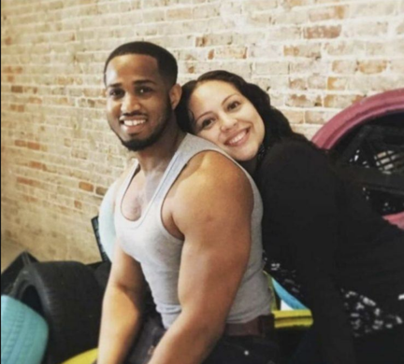

Gerren Taylor

On the day that Dr. Henry died, Gerren Taylor (née Ashley Taylor Gerren) got the Johnson & Johnson jab on April 3, in Los Angeles, with no public to-do about it, though she was a celebrity, like Midwin Charles. Hired by LA Models, at the tender age of 12, to strut the runways as their youngest-ever property, then dumped at 14, because, the agency told her, her body had grown "too big"—a shock that pushed her into a depression, and an eating disorder—Taylor rebounded with a starring role in "Baldwin Hills," the BET reality TV show that aired from 2007 to 2009, showcasing the love lives of the teen-aged kids of Baldwin Hills' rich-and-famous black residents. Taylor's stardom enabled her to speak out from her bruising experience of rejection by the agency, urging girls not to strive, impossibly, to emulate the "body image" rampantly projected by the media. She went on to great success as an entrepreneur, with Myoko's Closet, a children's clothing company named after her daughter.

On April 12, eight days after her injection, Taylor, 30, died in her sleep—"from unknown causes," reported Essence.
"Her cause of death is as yet unknown," the New York Post reported. "However, Essence reported that it may have been related to the reality TV show star's battle with the autoimmune disease lupus as she was reportedly on dialysis at the time of her death." The same story ran in The Sun and Daily Mail (the Post's British counterparts), also attributed to
Essence—which now makes no mention of dialysis. That Taylor's death "may [well] have been related to" her recent jab went unreported by the media, while it was noted by her friends, on "social media": "I told you not to get that vxxxxxe ash f***," one wrote bitterly on Instagram. "She said she took the mRNA jab; that's either Pfizer or Moderna," wrote another friend, Natasha James, on Facebook. (Taylor is survived by Myoko, her 7-year-old daughter.)

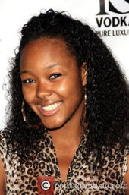

NaTalia Johnson

Two weeks after Taylor's death, on April 24, NaTalia Johnson, a former prima ballerina living now in Sacramento, updated her Facebook profile to tell her online friends that she had been injected (without noting which "vaccine" was used), and, as the upbeat text around her photo indicates, to urge others to get "vaccinated," too:

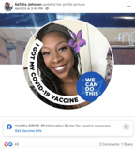

The native Texan (born in Lubbock) had retired to Sacramento in 2013, to serve as artistic director of the Natalia Johnson Conservatory of Ballet. Her story is remarkable. Having beat scoliosis (by wearing a back brace 23 hours a day, her one free hour devoted to ballet), then graduating from Lubbock High School with honors, Johnson set off for New York, with a scholarship to study dance at Juilliard, but through a chance encounter ended up at the Dance Theater of Harlem, starting an illustrious career that had her performing with the Urban Ballet Theater, Ballet Noir, Renaissance Ballet, Collage Dance Collective, and, in her hometown, Ballet Lubbock. Twice honored as an International Ballet All-Star, Johnson studied at the Alvin Ailey Dance Theater, taught master classes at schools and theaters nationwide, and also taught and choreographed New York City's public schools. Upon retiring from the stage, Johnson moved to Sacramento, opening her own conservatory there, while teaching in an elementary school, and also helping her sister, Candida, to graduate over 800 young women from the Girls Self-Esteem Program Academy, by mentoring them in "poise, grace, dignity and self-respect."

On May 7, 13 days after her injection, Johnson came home from work at 9:30 p.m., telling Candida that she felt horribly "tired"—she was crying because of it—and sick enough to see the doctor, but decided she would go next day. The sisters put on a movie starring Michael B. Jordan, and had fun watching it together, NaTalia lying on the bed; then, suddenly, "she sat up with a shocked look on her face, and held out her arms to me," recalled Candida, who felt her sister's body "tightening up," then going limp. She and a neighbor struggled to revive her, using CPR, until the EMTs arrived, and also tried for half an hour, to no avail: Natalia Johnson was gone, at 37—due either to "a stroke, brain aneurysm or a heart attack," surmised Candida (who didn't mention the injection, nor did any of the press coverage of NaTalia's death).

Simone Scott

On May 1, a week before NaTalia Johnson’s death in Sacramento, Simone Scott, a freshman at Northwestern University, in Evanston, Illinois (just north of Chicago), received her second dose of the Moderna serum, hoping it would not affect her as the first one did. That shot, on April 3, had laid her low for several days of what felt like a bad flu, followed by a lingering fatigue; so it was a relief for her, her mother and stepfather back in Mason, Ohio, and her dad in Washington, D.C., that her second shot had no immediate side effects. Now “fully vaccinated,” Simone headed into her last month of spring semester classes with the same acuity, determination and strict discipline that she had shown in all her efforts since fifth grade, when she decided to become a journalist, with an expertise in law. To that end, she was double-majoring in broadcast journalism and political science/pre-law, working toward two bachelor’s degrees, with her sights set on Harvard Law School for her J.D.

The feeling of relief after her second shot did not last long. On May 9, when she came home on a surprise visit for Mother’s Day, Simone seemed tired, and told her mother, Valerie Kraimer, that she’d been having nosebleeds. Back in Evanston on May 12, she made an appointment for a virtual check-up with a doctor who told her she was suffering from allergies. On May 13, she woke up with a low fever, and went to the student infirmary, where she tested negative for COVID-19, flu and other viruses; and though her heartbeat was irregular, they let her go, telling her to go to the ER if things got worse. On May 14, she came back with a sore throat, and was given a prescription for an anti-viral drug.

On Sunday, May 16, Simone could not get up, or eat. “Dad, I feel so dizzy,” she texted Kevin Scott. “I cannot get out of bed.” Her mother packed a bag, and started the long drive to Evanston; Kevin Scott called the Northwestern campus police, asking them to check up on his daughter at her dorm. (He had to talk them into it.) When they finally did, they found she couldn’t walk, and called an ambulance. On the way to North Shore Hospital, Simone went into cardiac arrest, requiring CPR, which barely saved her, as her heart was no longer functioning; so they rushed her into surgery, to insert a balloon pump in the failing organ. It didn’t work, so, next day, they placed her on a heart-lung bypass called an ECMO. That didn’t work either.

The doctors diagnosed it as a case of severe myocarditis—inflammation of the heart, thinking that some virus had attacked it. By May 20, they decided that a heart transplant might be the only way for Simone to survive, so she was moved to Northwestern Memorial Hospital, where, on May 23, doctors carried out the transplant. Although the new heart soon began
to beat as hoped, so it seemed that she might make it, her lungs had been badly damaged, and infected by the immunosuppressive drugs she needed for the transplant to succeed. She hung on, intubated, for a little over three weeks, and died at 11:19 a.m. on June 11, at the age of 19.

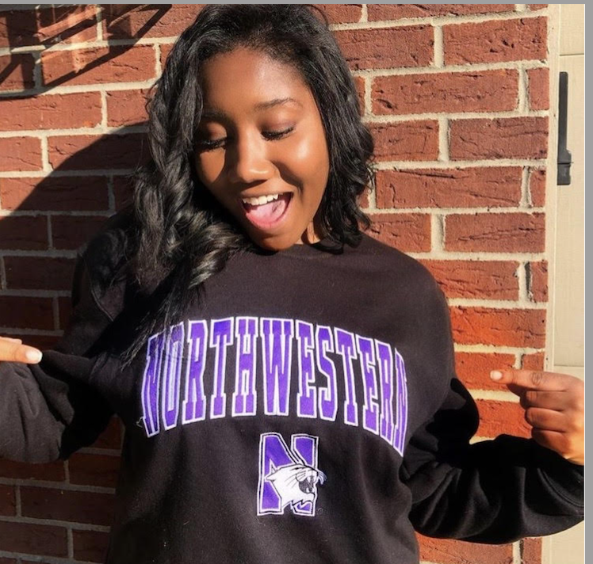

Ayesha K. Faines

Throughout the weeks that Gerren Taylor, NaTalia Johnson and Simone Scott lived after their injections, Ayesha K. Faines regaled her online followers with proud updates on her status as a “fully vaccinated” African-American, having got her second Pfizer jab at some point in mid-March. A former TV journalist in Jacksonville and New York City, the Yale-educated Faines was now nationally famous as a panelist on “The Grapevine,” a YouTube-based talk show featuring up to a dozen black millennials, hashing over topics such as Critical Race Theory, black/Latino relations, (white) racism as a mental illness, Bruno Mars as cultural appropriator and “the colonization of black beauty.”

On that last subject Faines was an especially compelling speaker, not just on “The Grapevine” but in all of her endeavors both online and (pre-COVID) as a public speaker. “A brave new voice for feminine power,” as her LinkedIn profile describes her, the dauntingly articulate (and visually arresting) Faines was the founder of Women Love Power, a company devised “to help women develop their authentic power,” and, as a columnist for Zora Magazine, “routinely explore[d] the intersection of love and power.” “Sought after for her expertise in mythology, race, and gender politics,” Faines was also a prolific poster on Instagram and (especially) Twitter, where she not only exulted in her own injections, but also voiced contempt for black Americans who were refusing to get jabbed.

While that majority regard the COVID-19 “vaccination” drive as yet another oblique white attempt to kill them off (about which more below), Faines saw the shots not as inimical, in any way, to African-Americans, but as wholly reconcilable with blackness: “Just know that I’m melanated and vaccinated,” she tweeted playfully on March 30. Focused, as she was, on “feminine power,” Faines must have especially disliked the captivity of lockdown, and felt especially liberated by her second shot in early April, which meant she now was free to do her exercises (she was a competitive salsa dancer) outside home: “I’ve been practicing at home during quarantine [sic], but praise God I’m vaccinated and going back to the studio in the beginning of may!” she tweeted on April 10.

Unlike the majority of African-Americans, Faines saw the “vaccines” not as some covert poison used by whites to lower black numbers—a view she candidly disdained, in this tweet on March 5:

“‘The percentage of [Blacks] who don’t want to take the vaccine right now are reluctant because of misinformation or no information’ and not necessarily because of concerns of [sic] historical racial bias in medicine.

Thus Faines quoted Cornell Belcher, a pollster whose new study of black “vaccine-hesitancy,” conducted for the National Urban League, now showed (he said) that black people distrusted the injection program not because of their long history of grotesque abuse by the American medical establishment (Tuskegee is the least of it), but because they’re either “misinformed” or ignorant—and, therefore, in urgent need of being properly “informed” ASAP, presumably by, say, the National Urban League, with generous funding by, say, Pfizer, and/or the Gates Foundation (both of them, as it happens, generous donors to the National Urban League), so that all those uninjected will now finally see the light, and get the jab.

Having tweeted Belcher’s claim as if it were a valid observation, Faines charged that all too many African-Americans were “vaccine-hesitant” not because of the atrocious history of black suffering at the (white) hands of US doctors, but because they had been duped by Donald Trump and other white Republicans:

Not to mention the same cadre that downplayed COVID, like TRUMP and Desantis, were among the FIRST to get the vaccine. That’s the game. — Sow seeds of doubt. Discourage marginalized groups from being vaccinated so that wealthy whites have an abundant supply

I wish it were appropriate to disentangle the illogic of that tweet, to demonstrate how much more dangerous it is to hold that view of those “vaccines” than to be healthily suspicious of them. I wish it were appropriate, because it would be if Ayesha Faines herself did not soon inadvertently, and tragically, disprove what she and Belcher wrote about the ignorance and/or delusion of that black majority.

Having been knocked flat by her first jab in mid-March (“The first Pfizer shot had me down for the count,” she tweeted on April 3), Faines bounced right back to her packed schedule, keeping at it right through April, May and most of June. On June 28, she posted 25 tweets, and her last Facebook post at 10:45 p.m. that night. Those comprised her final words online. She died four days later, at 35, on July 2.

Faines’ sudden death received much online coverage, with no cause given. A few days later, her family released a statement, reported first by Zora, the magazine that ran Faines’ columns, and then by News4Jax, the Jacksonville news outlet for which she’d worked as traffic anchor, as well as BET and a few other sites online: “Ayesha K. Faines was born with asthma and multiple severe food allergies. On June 29, 2021, Ayesha suffered a fatal anaphylactic reaction from an unknown allergen.”

There was no mention of Faines’ “vaccination” in the coverage of her death, nor, with some very few exceptions, did any of her multitude of online mourners mention it. Only the COVID Blog and Sandra Rose—both COVID-dissident websites—noted her injections as the likely cause of death. If she did die of anaphylactic shock, it was more likely due to Faines’ two Pfizer shots than to anything she ate, since such fatal food allergies are now far more unusual than such severe allergic reactions among those jabbed with the mRNA “vaccines”—a side effect that, back in January, the CDC assured us was extremely rare, which we may take as meaning that it isn’t all that rare; and more recent data from Japan and Israel suggest that it is not so uncommon after all.

Maurice Shepperson

Five days after Ayesha Faines died in New Jersey, Maurice Reginald Shepperson (who went by “Reggie”) drove himself to the ER of Henderson Hospital in Las Vegas, wracked with pain all over, unable to breathe or focus—in such bad shape that he skidded off the hospital parking lot onto the sidewalk. The 36-year-old flight attendant (a Southwest Airlines employee) had fallen ill soon after returning from a trip to Hawaii, with his mother, Dawn. Both had tested negative for COVID-19, several times. Shepperson quarantined as soon as he felt sick (Dawn left his meals outside his door), then tested positive, and just kept getting worse.

They had him in the ICU for over four weeks, much of the time on a ventilator. Every day, Dawn talked to him on FaceTime, praying with him every hour, on the hour. (“He would talk when he could,” she said. “He would give me a thumbs-up when he could.”) On Tuesday, Aug. 10, the hospital called Dawn to let her know that Reggie had passed on.

Although we don’t know exactly when he was injected, the fact that Shepperson was “fully vaccinated” led the news in dozens of pieces published nation- and world-wide, many of them with the exact same headline: “Fully vaccinated Southwest flight attendant dies of COVID-19.” The implication of that headline, and many others near-identical, is (of course) that this was “news” because it was an oddity, like “Man Bites Dog”—a point spelled out in several of the articles: “Severe infections of COVID-19 among those who are vaccinated are extremely rare,” declared the New York Post, “even as the highly contagious Delta variant has spread across the United States.”

The latest figures posted on the CDC’s website showed that just 8,054—or 0.005 percent—of the 166 million Americans who’ve been fully vaccinated against COVID-19 had suffered serious breakthrough infections causing hospitalization or death as of Aug. 9.

Thus the “fully vaccinated” Reggie Shepperson’s untimely death was misreported, as (a) “extremely rare” (which it most certainly was not), and, therefore, (b) as an untimely death not caused by his “vaccination”—which, as we have seen, is how those other nine untimely deaths of black Americans were also variously misreported; and they are not the only ones, as we shall see.

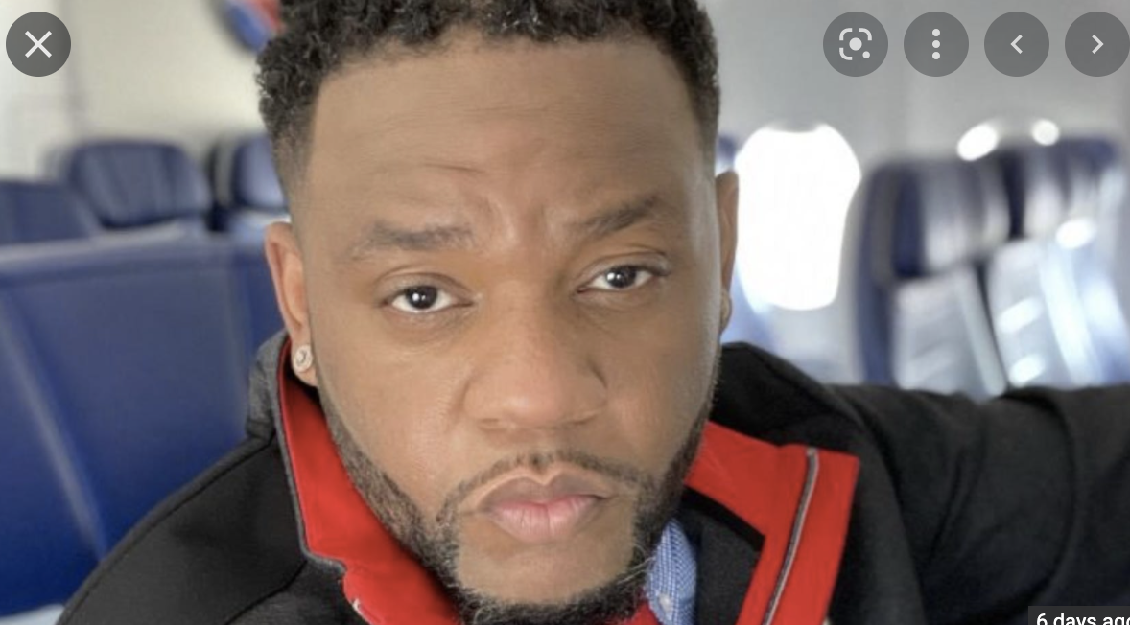

We will begin Part 2 of this essay by revisiting the question that I posed at the beginning: “What happens when a propaganda blitz misfires, and proves (or seems to prove) the very truth it was devised to blow away?” We will start to answer that key question by reviewing all the ways in which “our free press” ensured that We the People not see the significance of those ten deaths—i.e., what those “vaccines” are obviously doing to us all,
and by design.

